

|  |  |  |  |  |  |  |  |  |
| --- | --- | --- | --- | --- | --- | --- | --- | --- |
|  | | | | | | | | |
|  | | REPORT TITLE | | | | |  | |
|  |  | | | | | | |  |
|  | | | |  |  | | | |
|  | | | | Charlie Thomas |  | | | |
|  | | | | 04/04/2024—Excel and Tableau— **Special Thanks to Mr. Yusuf Satilmis** |  | | | |
|  | | |  | | |  | | |



|  |  |  |  |  |  |  |  |  |
| --- | --- | --- | --- | --- | --- | --- | --- | --- |
|  |  | | |  |  | | |  |
|  | Table of Content | | | | | | |  |
|  |  | | |  |  | | |  |
|  |  | |  | | |  | |  |
|  |  |  | |  |  |  | | --- | --- | --- | | S.No | Particular | Page number | |  |  |  | |  |  |  | |  |  |  | |  |  |  | |  |  |  | |  |  |  | |  |  |  | |  |  |  | |  |  |  | |  |  |  | |  |  |  | |  |  |  | |  |  |  | | | |  |  |  |
|  | | | | |
|  |  |  |  |
|  |  |



|  |  |  |  |  |
| --- | --- | --- | --- | --- |
|  |  |  |  |  |
|  | Task1:Policies and Procedures | | |  |
|  |  |  |  |  |

When working with data, especially in contexts involving sensitive or personal information, it's crucial to adhere to a set of policies to ensure ethical, legal, and secure handling of the data. Here's an outline of some key policies that should be considered:

1. **Data Privacy Policy**:
   * Clearly outline the types of data collected, including personally identifiable information (PII).
   * Specify the purposes for which the data is collected and how it will be used.
   * Detail procedures for obtaining consent from individuals for data collection and processing.
   * Define guidelines for data retention and deletion to ensure compliance with privacy regulations.
2. **Data Security Policy**:
   * Establish protocols for securing data against unauthorized access, disclosure, or alteration.
   * Implement encryption techniques for data transmission and storage.
   * Enforce access controls and user authentication mechanisms to restrict access to authorised personnel only.
   * Define procedures for incident response and data breach notification to mitigate potential risks.
3. **Data Retention Policy**:
   * Specify the duration for which data will be retained based on regulatory requirements and business needs.
   * Define criteria for archiving or deleting data once it ends its retention period.
   * Ensure compliance with laws and regulations governing data retention in relevant jurisdictions.
4. **Data Quality Policy**:
   * Establish standards for data accuracy, completeness, and consistency.
   * Define procedures for data validation and cleansing to ensure high-quality data.
   * Implement mechanisms for regular data audits and validation checks.
5. **Compliance Policy**:
   * Ensure compliance with relevant data protection regulations such as GDPR, CCPA, HIPAA, etc.
   * Stay informed about updates and changes to data protection laws and adjust policies accordingly.
   * Conduct regular compliance assessments and audits to identify and address any non-compliance issues.
6. **Data Access and Sharing Policy**:
   * Define roles and responsibilities for accessing and sharing data within the organisation.
   * Implement controls to monitor and track data access and sharing activities.
   * Establish guidelines for securely sharing data with third parties, including vendors and partners.
7. **Ethical Data Use Policy**:
   * Promote ethical principles such as transparency, fairness, and accountability in data handling.
   * Prohibit unethical practices such as data discrimination or manipulation.
   * Encourage responsible use of data for legitimate purposes while respecting individual privacy rights.
8. **Training and Awareness Policy**:
   * Provide regular training sessions on data handling policies and procedures for employees.
   * Raise awareness about the importance of data privacy and security among staff members.
   * Ensure that employees understand their roles and responsibilities in safeguarding data.
9. **Governance and Oversight Policy**:
   * Establish a governance structure with designated individuals or committees responsible for overseeing data management practices.
   * Define reporting mechanisms for data-related incidents or breaches.
   * Ensure accountability by holding individuals accountable for non-compliance with data policies.
10. **Continuous Improvement Policy**:
    * Implement mechanisms for ongoing review and improvement of data policies and procedures.
    * Solicit feedback from stakeholders and incorporate lessons learned from past experiences.
    * Stay updated on emerging technologies and best practices in data management to adapt policies accordingly.

By adhering to these policies, organizations can promote responsible data-handling practices, mitigate risks, and build trust with stakeholders.

Adhering to data policies is essential for several reasons, especially when handling sensitive or personal information. Here's why it's crucial to follow these policies:

1. **Protecting Privacy Rights**: Data privacy policies ensure that individuals' privacy rights are respected by specifying how their personal information is collected, stored, and used. Adhering to these policies helps prevent unauthorized access or misuse of sensitive data, safeguarding individuals' privacy.
2. **Ensuring Data Security**: Data security policies are crucial for protecting data from cyber threats, such as hacking or data breaches. By implementing security measures such as encryption, access controls, and incident response protocols, organizations can minimize the risk of data breaches and maintain the confidentiality and integrity of the data.
3. **Compliance with Regulations**: Many jurisdictions have enacted data protection regulations such as GDPR, CCPA, HIPAA, etc., which impose legal obligations on organizations regarding the handling of personal data. Adhering to data policies ensures compliance with these regulations, reducing the risk of legal penalties, fines, or lawsuits for non-compliance.
4. **Maintaining Data Quality**: Data quality policies help ensure that the data used for analysis is accurate, reliable, and consistent. By adhering to data quality standards and conducting regular validation checks, data analysts can rely on high-quality data to make informed decisions and derive accurate insights.
5. **Building Trust and Reputation**: Following data policies demonstrates a commitment to ethical and responsible data handling practices, which can enhance trust and credibility with customers, partners, and other stakeholders. Organizations that prioritize data privacy and security are more likely to earn the trust of individuals and maintain a positive reputation in the market.
6. **Mitigating Risks**: Adhering to data policies helps mitigate various risks associated with data handling, including security breaches, data loss, regulatory violations, and reputational damage. By implementing comprehensive policies and procedures, organizations can proactively identify and address potential risks before they escalate into serious issues.

As a data analyst, it's crucial to be aware of these rules and policies for several reasons:

1. **Ethical Responsibility**: Data analysts have a responsibility to ensure that data is handled ethically and in compliance with relevant regulations and policies. Being aware of data policies helps data analysts make informed decisions about how to collect, analyze, and use data responsibly.
2. **Risk Management**: Data analysts often have access to sensitive or confidential information, making them responsible for protecting data from unauthorized access or misuse. Understanding data security and privacy policies allows data analysts to identify and mitigate potential risks to data integrity and confidentiality.
3. **Data Quality Assurance**: Data analysts rely on high-quality data to perform accurate analysis and generate reliable insights. By understanding data quality policies and procedures, data analysts can contribute to maintaining data quality standards and ensuring that the data used for analysis is accurate and reliable.
4. **Compliance Obligations**: Data analysts need to ensure that their data handling practices comply with relevant regulations and policies to avoid legal and regulatory consequences. Being aware of data privacy and security policies helps data analysts comply with legal obligations and prevent potential compliance violations.

Overall, awareness of data policies is essential for data analysts to perform their roles effectively, ethically, and in compliance with legal and regulatory requirements.

|  |  |  |  |  |
| --- | --- | --- | --- | --- |
|  |  |  |  |  |
|  | Task2 :Excel | | |  |
|  |  |  |  |  |

1. Set a password to protect the workbook

* **Password: 123456**

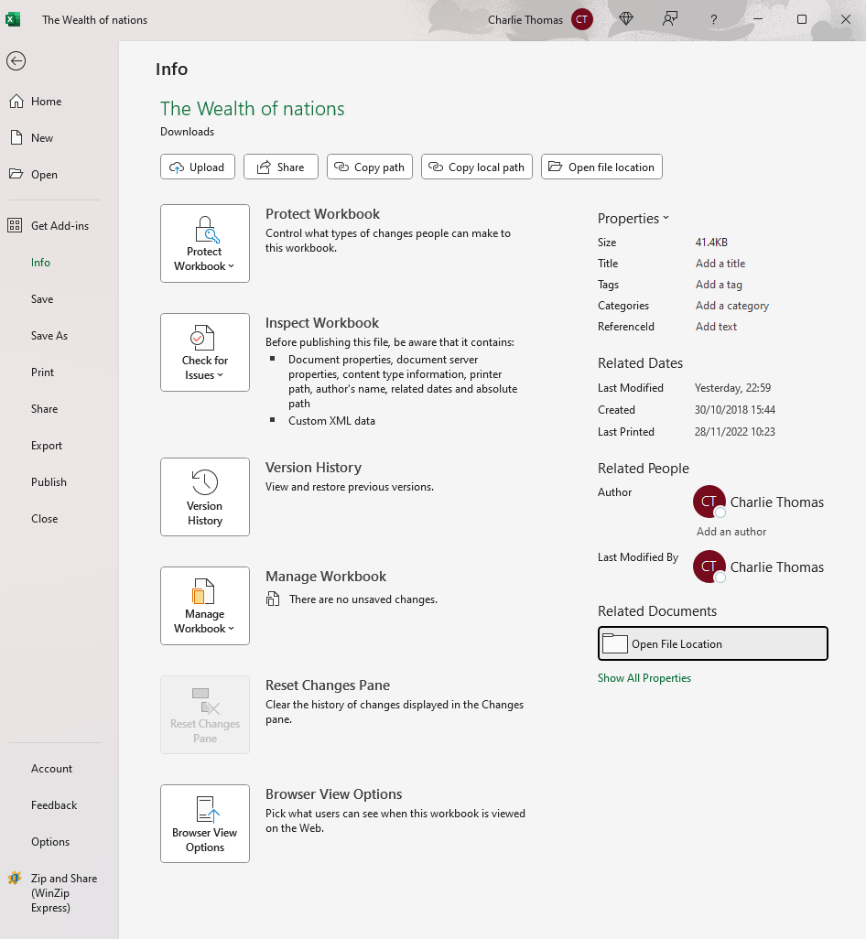

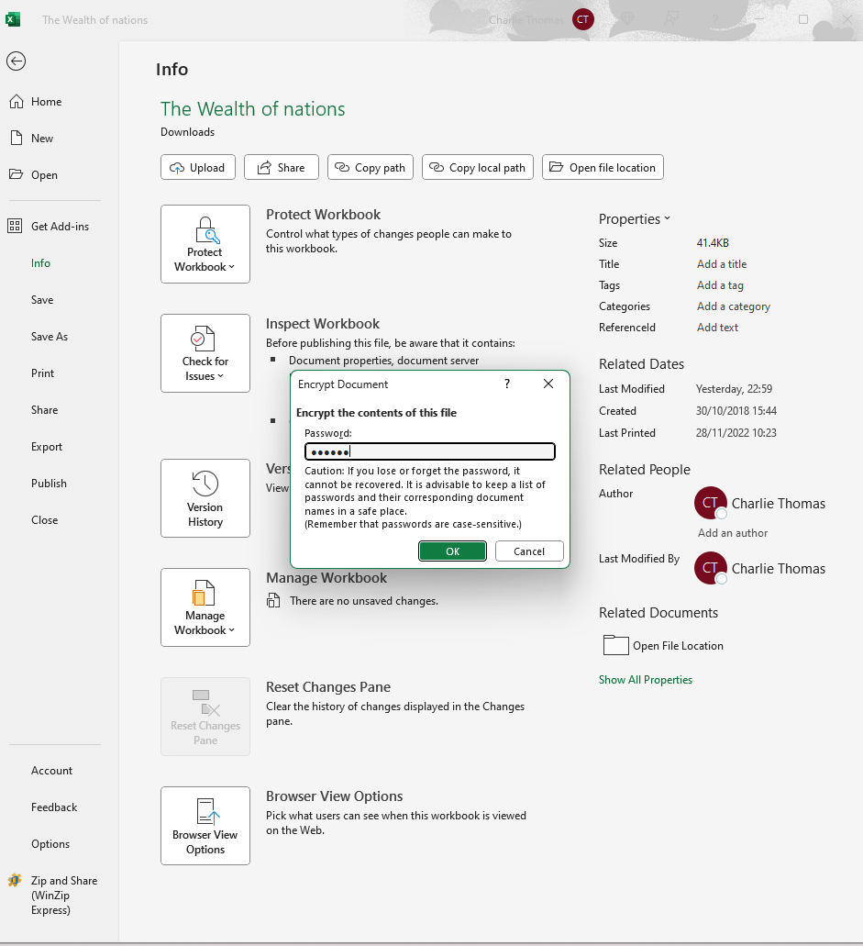

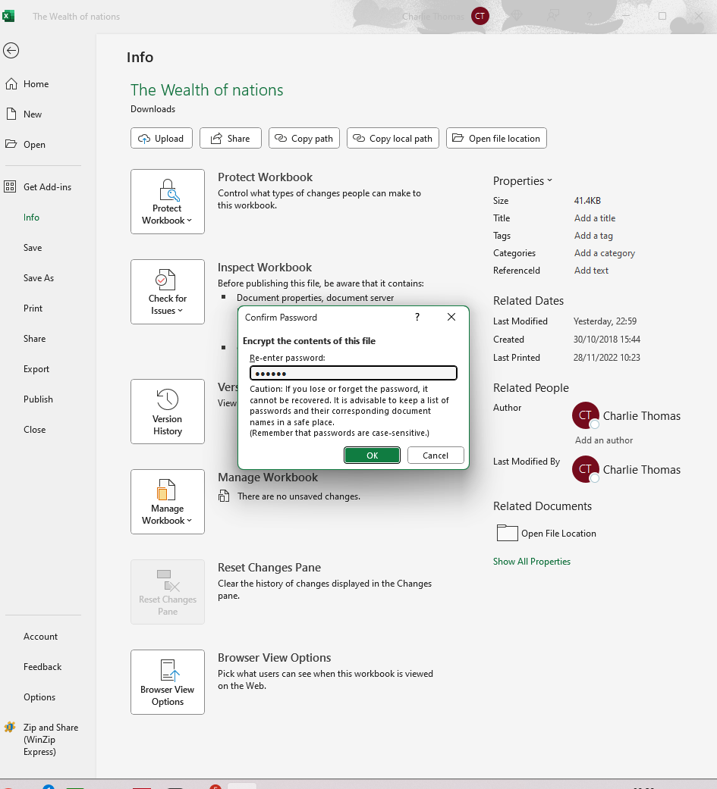

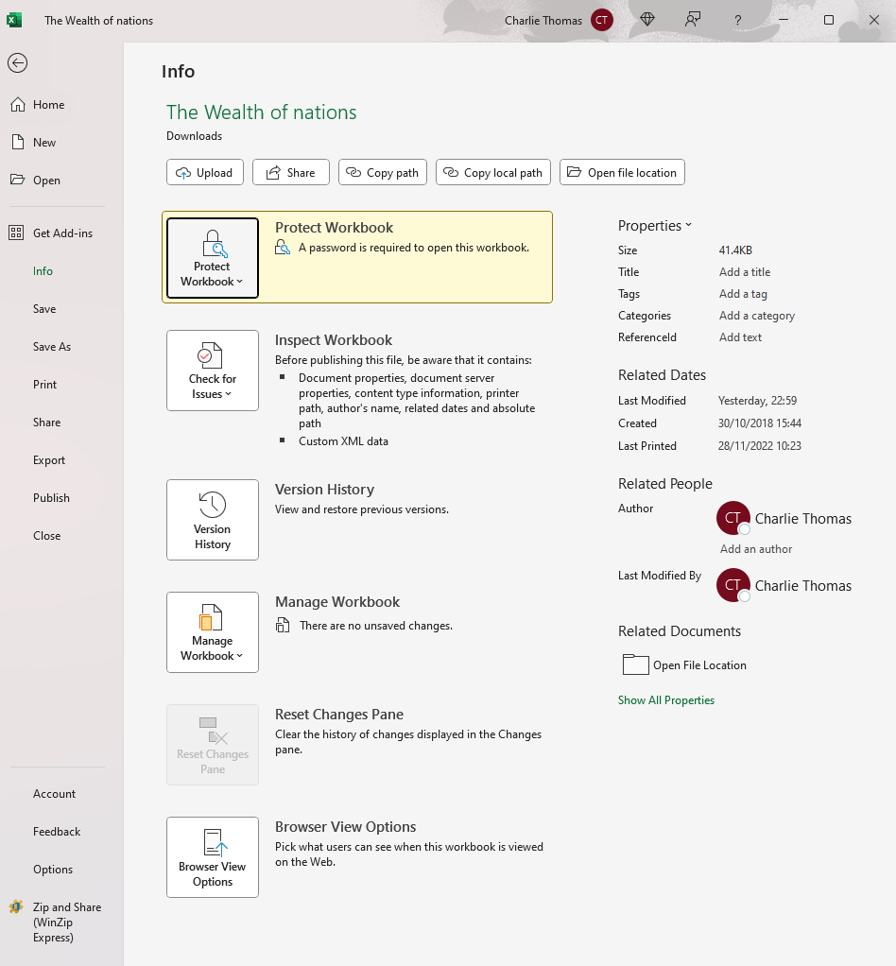

1. Highlight column C and change the data to display in British Pound symbol.

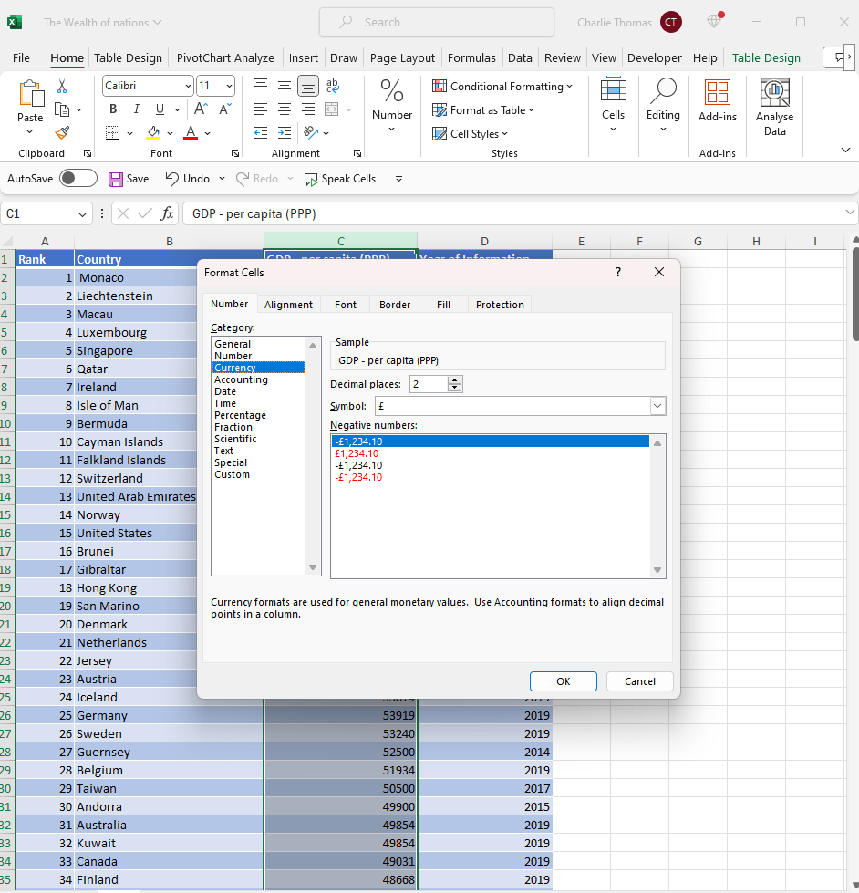

1. Turn the GDP sheet into a table.

|  |  |  |  |
| --- | --- | --- | --- |
| **Rank** | **Rank2** | **Rank3** | **Rank4** |
| 1 | Monaco | £190,513.00 | 2019 |
| 2 | Liechtenstein | £180,367.00 | 2018 |
| 3 | Macau | £123,965.00 | 2019 |
| 4 | Luxembourg | £115,874.00 | 2020 |
| 5 | Singapore | £97,341.00 | 2019 |
| 6 | Qatar | £90,044.00 | 2019 |
| 7 | Ireland | £86,781.00 | 2019 |
| 8 | Isle of Man | £84,600.00 | 2014 |
| 9 | Bermuda | £81,798.00 | 2019 |
| 10 | Cayman Islands | £71,549.00 | 2018 |
| 11 | Falkland Islands | £70,800.00 | 2015 |
| 12 | Switzerland | £68,628.00 | 2019 |
| 13 | United Arab Emirates | £67,119.00 | 2019 |
| 14 | Norway | £63,633.00 | 2019 |
| 15 | United States | £62,530.00 | 2019 |

1. Filter the table to display only the information for 2019

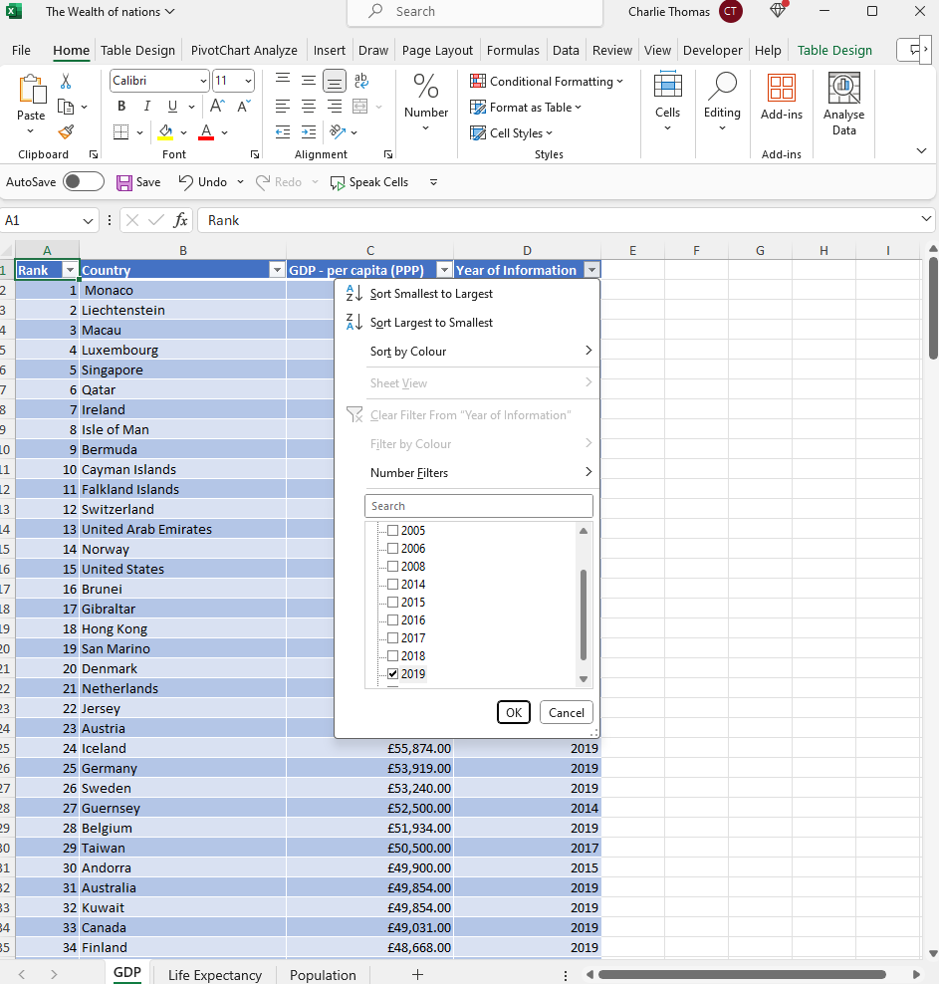

|  |  |  |  |
| --- | --- | --- | --- |
| **Rank** | **Country** | **GDP - per capita (PPP)** | **Year of Information** |
| 1 | Monaco | £190,513.00 | 2019 |
| 3 | Macau | £123,965.00 | 2019 |
| 5 | Singapore | £97,341.00 | 2019 |
| 6 | Qatar | £90,044.00 | 2019 |
| 7 | Ireland | £86,781.00 | 2019 |
| 9 | Bermuda | £81,798.00 | 2019 |
| 12 | Switzerland | £68,628.00 | 2019 |
| 13 | United Arab Emirates | £67,119.00 | 2019 |
| 14 | Norway | £63,633.00 | 2019 |
| 15 | United States | £62,530.00 | 2019 |
| 16 | Brunei | £62,100.00 | 2019 |
| 18 | Hong Kong | £59,848.00 | 2019 |
| 20 | Denmark | £57,804.00 | 2019 |
| 21 | Netherlands | £56,935.00 | 2019 |
| 23 | Austria | £56,188.00 | 2019 |
| 24 | Iceland | £55,874.00 | 2019 |
| 25 | Germany | £53,919.00 | 2019 |
| 26 | Sweden | £53,240.00 | 2019 |
| 28 | Belgium | £51,934.00 | 2019 |
| 31 | Australia | £49,854.00 | 2019 |
| 32 | Kuwait | £49,854.00 | 2019 |
| 33 | Canada | £49,031.00 | 2019 |
| 34 | Finland | £48,668.00 | 2019 |
| 35 | Saudi Arabia | £46,962.00 | 2019 |
| 36 | United Kingdom | £46,659.00 | 2019 |
| 38 | France | £46,184.00 | 2019 |
| 39 | Bahrain | £45,011.00 | 2019 |
| 40 | EU | £44,436.00 | 2019 |
| 41 | Malta | £44,032.00 | 2019 |
| 42 | New Zealand | £42,888.00 | 2019 |

1. Next create a chart that will only display the following data ‘Rank, Country and GDP - per capita (PPP). The chart can be anything as long as it is suitable.
   1. 6. Using your creative skills edit the chart
   2. a. Add a title
   3. b. Add X and Y axis labels
   4. c. Make the chart visually pleasing
   5. 7. Move the chart to a new sheet tab and label with a suitable name
   6. 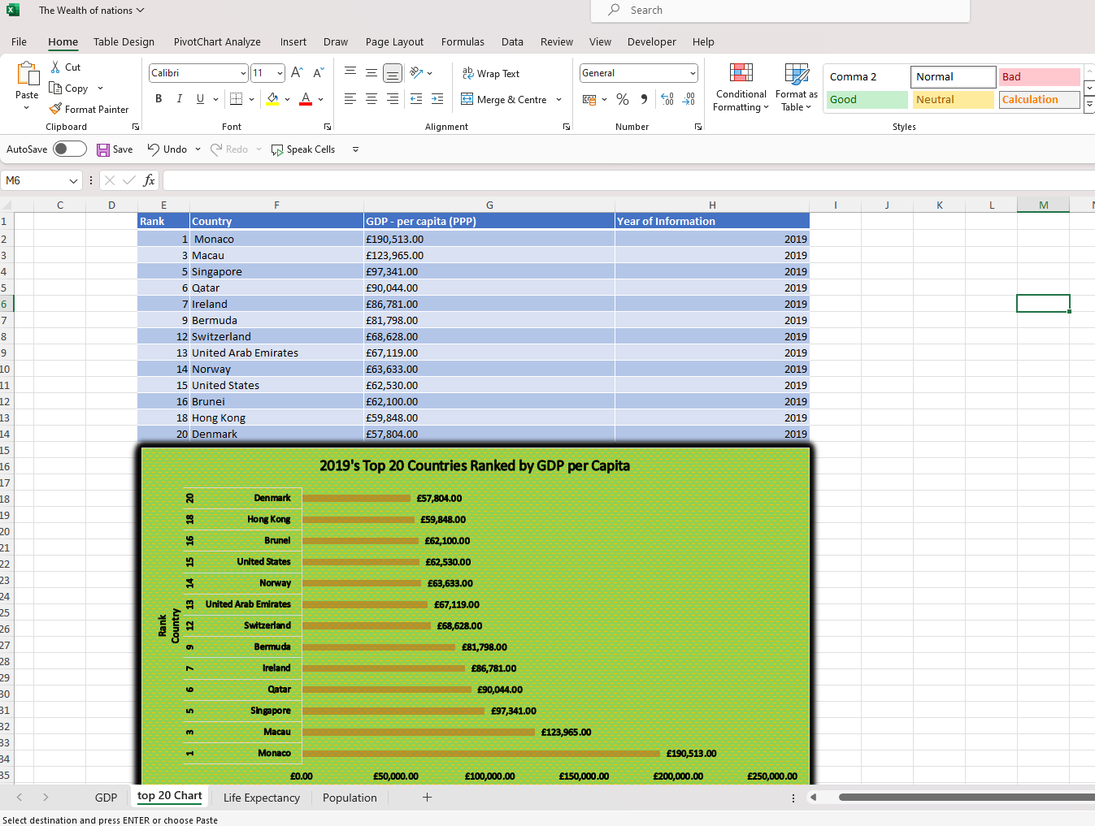
   7. 8. Create a sort for the top 20 highest ranking counties

|  |  |  |  |
| --- | --- | --- | --- |
| **Rank** | **Country** | **GDP - per capita (PPP)** | **Year of Information** |
| 1 | Monaco | £190,513.00 | 2019 |
| 3 | Macau | £123,965.00 | 2019 |
| 5 | Singapore | £97,341.00 | 2019 |
| 6 | Qatar | £90,044.00 | 2019 |
| 7 | Ireland | £86,781.00 | 2019 |
| 9 | Bermuda | £81,798.00 | 2019 |
| 12 | Switzerland | £68,628.00 | 2019 |
| 13 | United Arab Emirates | £67,119.00 | 2019 |
| 14 | Norway | £63,633.00 | 2019 |
| 15 | United States | £62,530.00 | 2019 |
| 16 | Brunei | £62,100.00 | 2019 |
| 18 | Hong Kong | £59,848.00 | 2019 |
| 20 | Denmark | £57,804.00 | 2019 |

* 1. 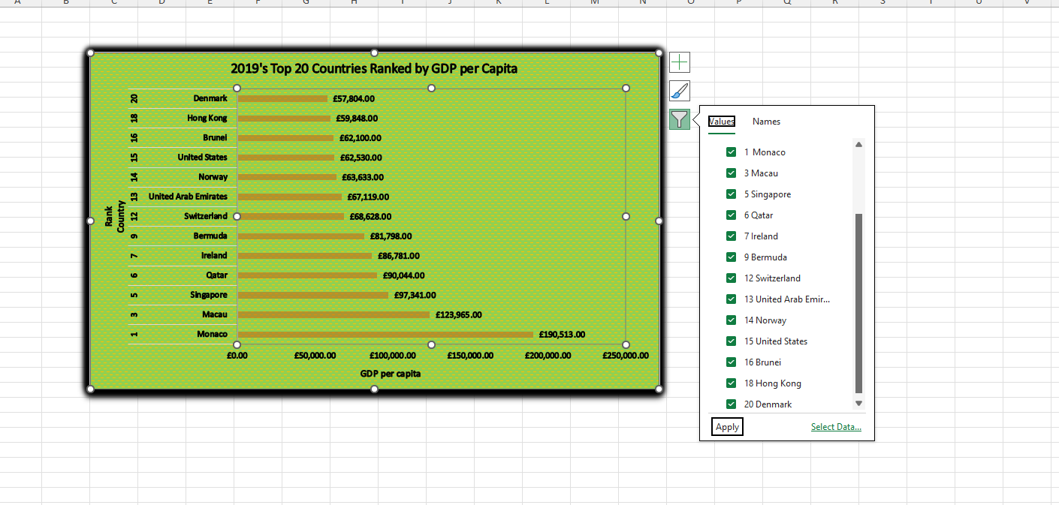
  2. 9. Next create a new Bar chart to display the 20 highest-ranking countries from your sort and then move the chart to be underneath the table, as shown below.

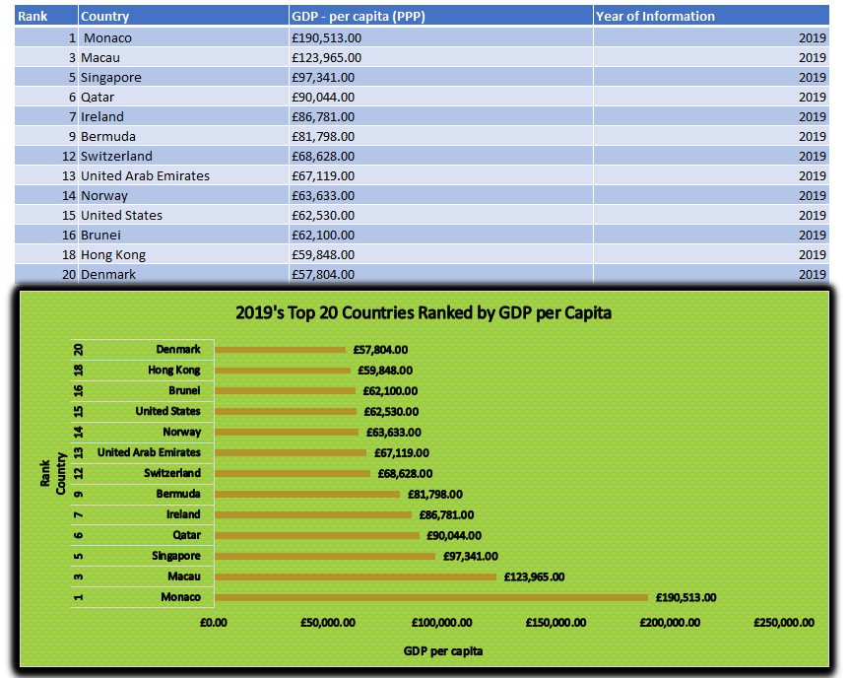

1. 10. Colour the background by highlighting the area underneath the table as shown below. Find the add a fill colour icon and select a colour.
2. 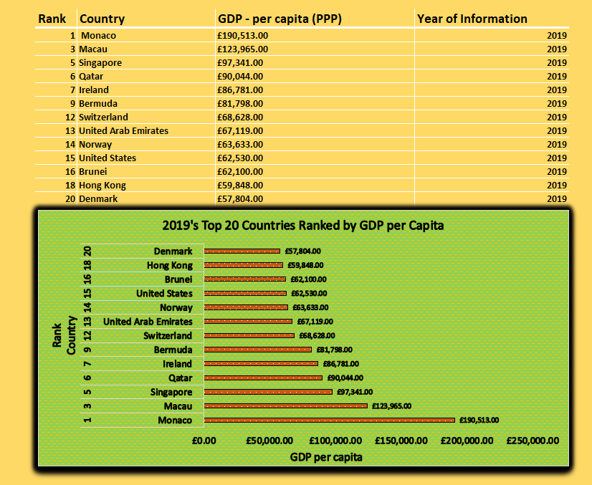

**Data Cleaning**

1. The total population of each country is represented by the 'Smartphone Users' column. Either the column name has to be changed to the appropriate name or the column has to be populated with the correct smart user's data.
2. Missing data in Column: Country was sourced externally from the website: [World Population by Country in 2020 (World Map) | database.earth](https://database.earth/population/by-country/2020#:~:text=In%202020%2C%20the%20world%20reached,of%201%2C396%2C387%2C127%20people%20in%20total.)
3. Column Country Geographical Data type converted to text data type
4. A New Worksheet named Population was created by performing data cleaning smartphone user worksheet

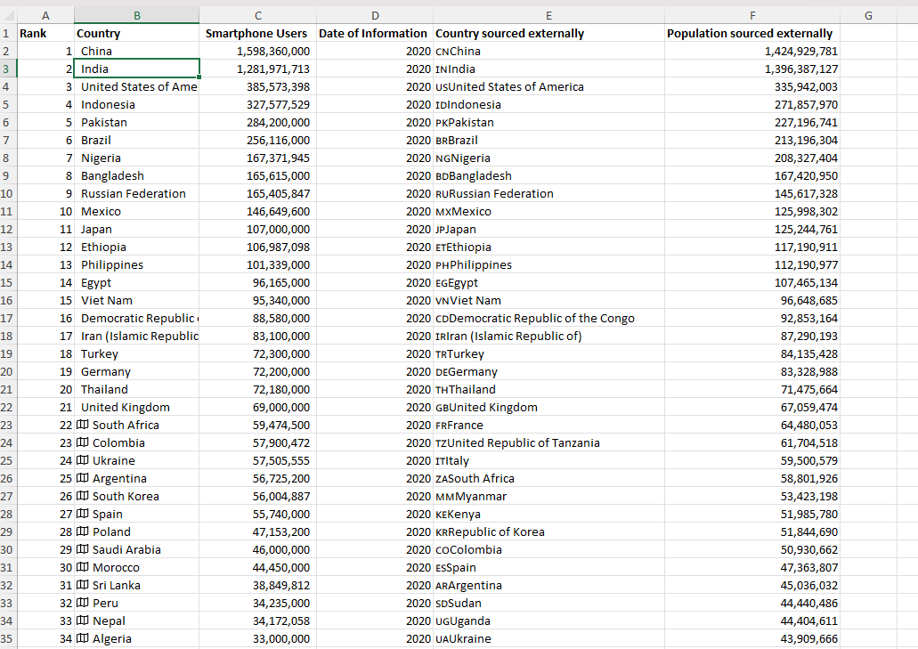

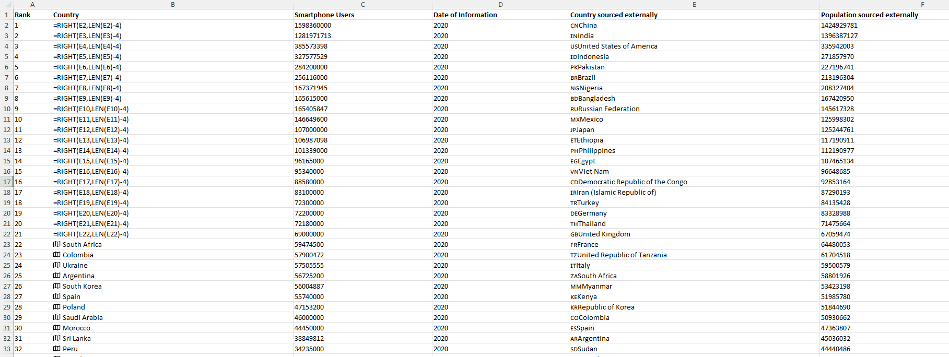

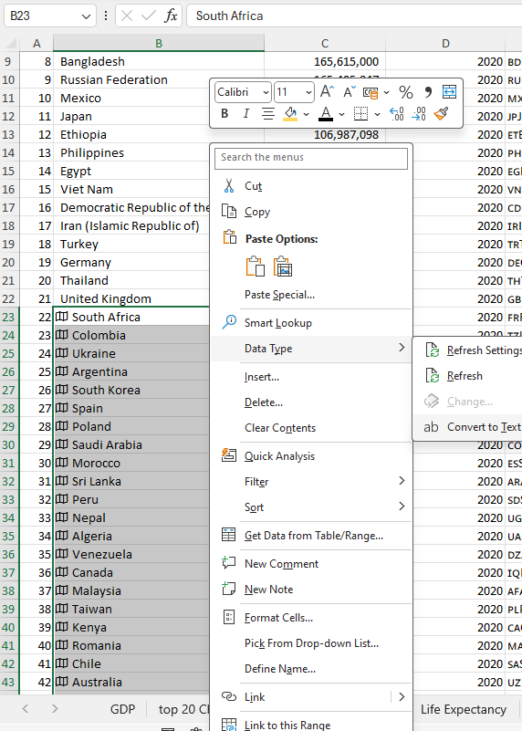

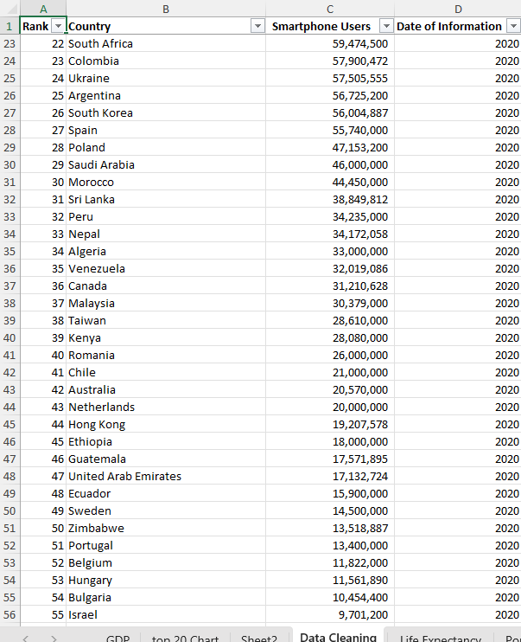

|  |  |  |  |  |
| --- | --- | --- | --- | --- |
|  |  |  |  |  |
|  | Task3:Tableau | | |  |
|  |  |  |  |  |

1) Import data

2) Set relationships:

You have three sheets and the common column for all of them is country, so the visual arrangement of the sheets does not matter Only the columns that you use to create the relationship matters. You can arrange the sheets in a straight line as seen below:



Or you can arrange it like this:



3) Check data types.

4) Build charts

You are now ready to create charts. Please make sure to create at least 4 visuals. There is no upper limit.

Client Requirements

The client is colour blind and requested you to bear this in mind when building your dashboard. The client is only interested in the top 20 highest ranking countries. All your visuals should be for the top 20 highest ranking countries.

5) As you create your charts, if you see a little grey box containing a count of null values, select the filter option.

6) Build your dashboard.

|  |  |  |  |  |
| --- | --- | --- | --- | --- |
|  |  |  |  |  |
|  | Reflection | | |  |
|  |  |  |  |  |